National University of Computer and Emerging Sciences



Lab Manual 3
SE3003 – Web Engineering

Course Instructor | Sir Mudassir
Lab Instructor(s) | Marwa Khan
Section | BSE 6A
Semester | Spring 2024

Department of Computer Science
FAST-NU, Lahore, Pakistan

Lab Manual 3 – HTML/CSS
Important Note:
− You may find the syntax to accomplish these exercises from the lecture demo.
− Names of your submission files should start with your roll number throughout this semester.
− Make sure that the interface of your program is user friendly i.e. properly display information.
− Properly follow the coding standards.

1. Exercise – Create a Responsive web page using Grid/Flex

2. Use Positions instead of Margin and Padding

3. Use these Media Queries

/* Extra small devices (phones, 600px and down) */
@media only screen and (max-width: 600px) {...}

/* Small devices (portrait tablets and large phones, 600px and up) */
@media only screen and (min-width: 600px) {...}

/* Medium devices (landscape tablets, 768px and up) */
@media only screen and (min-width: 768px) {...}

/* Large devices (laptops/desktops, 992px and up) */
@media only screen and (min-width: 992px) {...}

/* Extra-large devices (large laptops and desktops, 1200px and up) */
@media only screen and (min-width: 1200px) {...}

Task 1 (Grid/Flex) 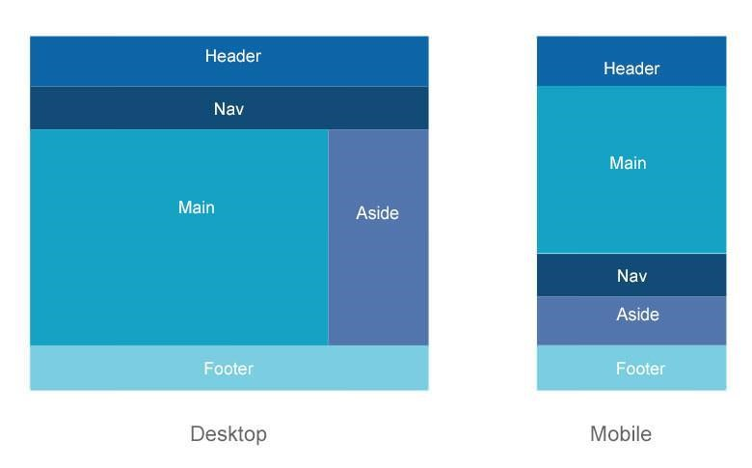

Task 2 (Positions)
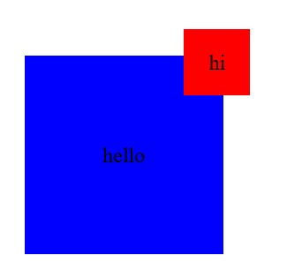

Task 3

Desktop view

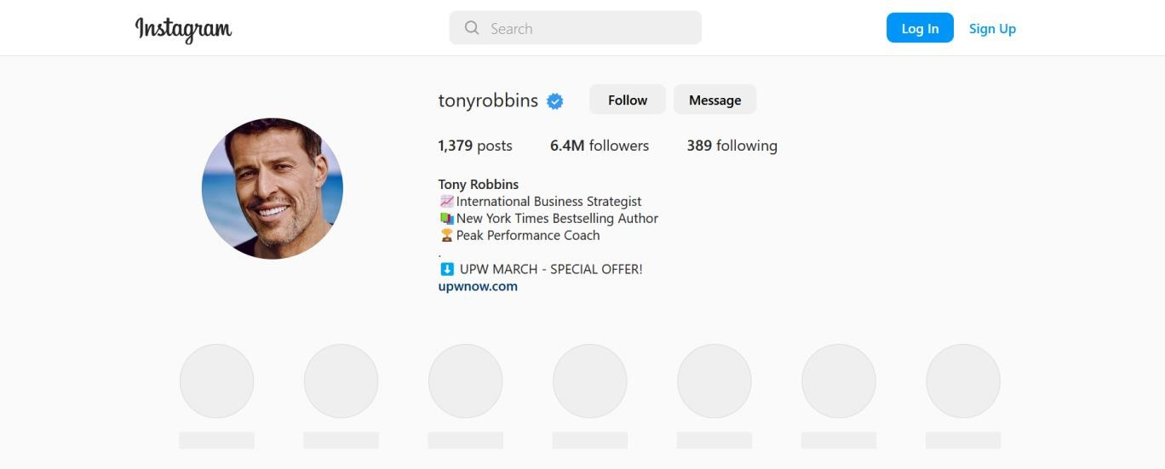

Mobile View
